# White box testing

## Children not moving to correct path node

### Problem

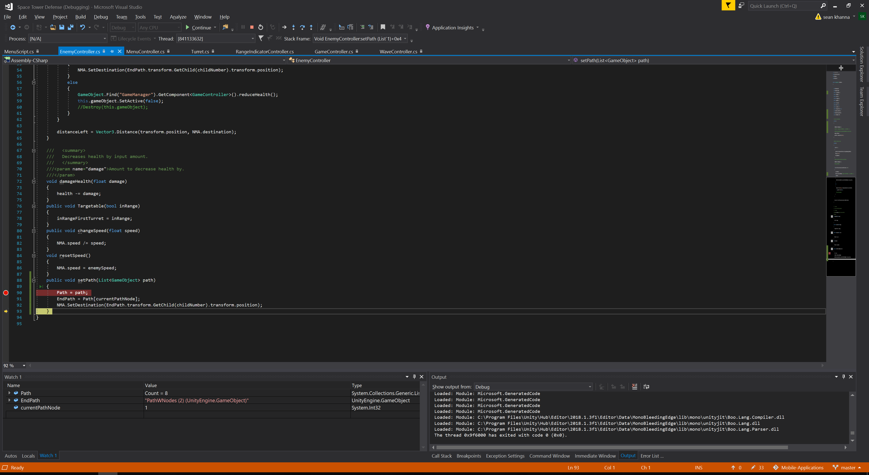

Path is already 1 node too far in. CurrentPathNode should be at 0.

### Solution

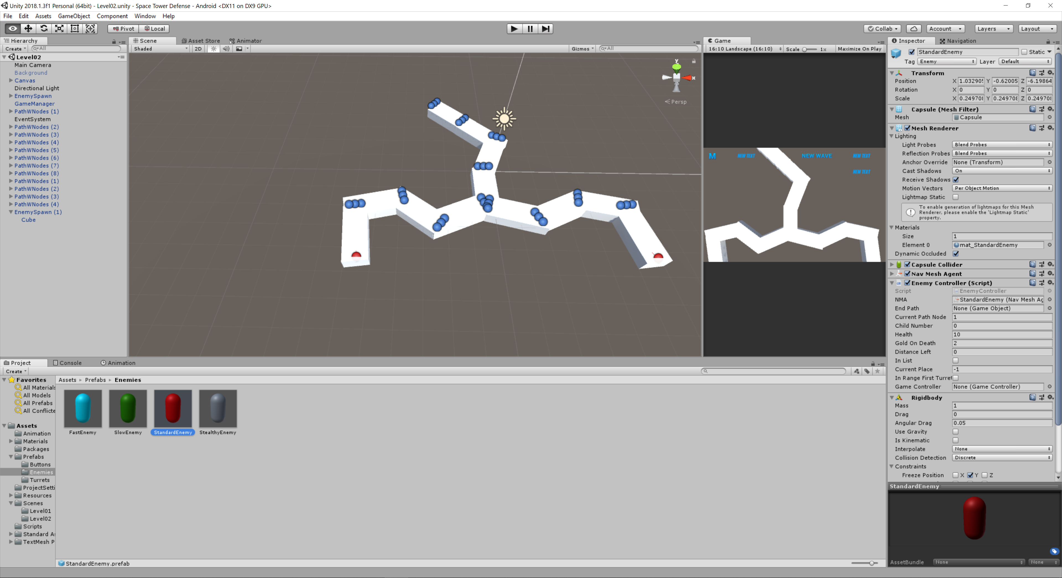

I forgot to change it in the inspector, so it was always resetting it back to default. To fix this I am going to make the variable private. So it can not be changed outside of the script.